* Web aps service in Azure <https://docs.microsoft.com/en-us/azure/app-service/overview>
* Create a Webapp 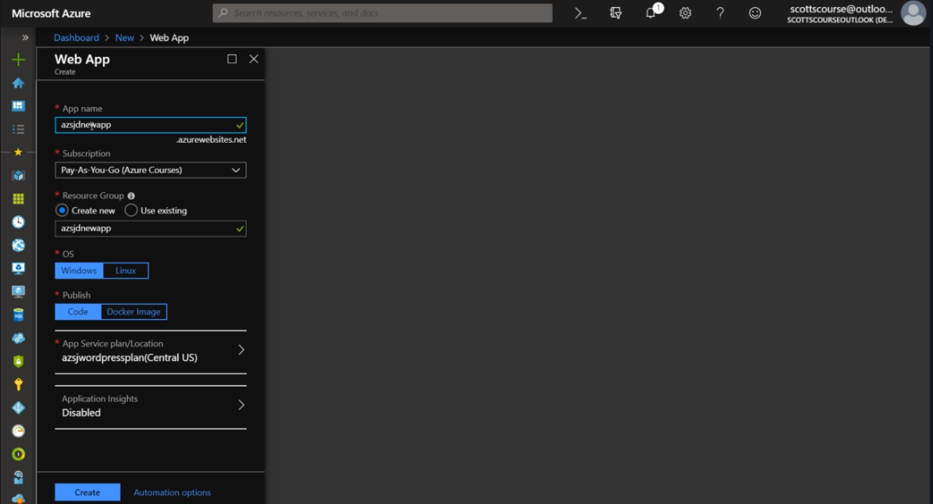
* In Windows we do not have to specify the language while creating but IN Linux we have to do that. 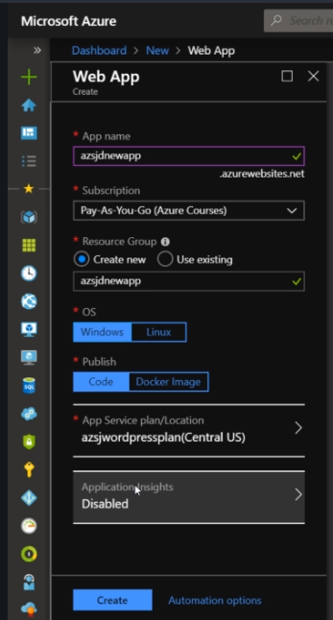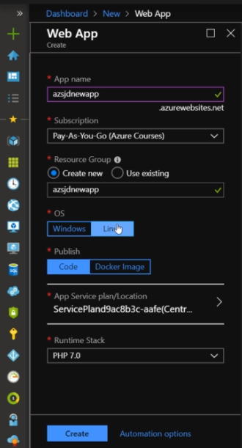
* We can develop it with the tools or we can use a docker image to use an image to deploy.
* App Service plan for the web app is very similar to a hosting plan. 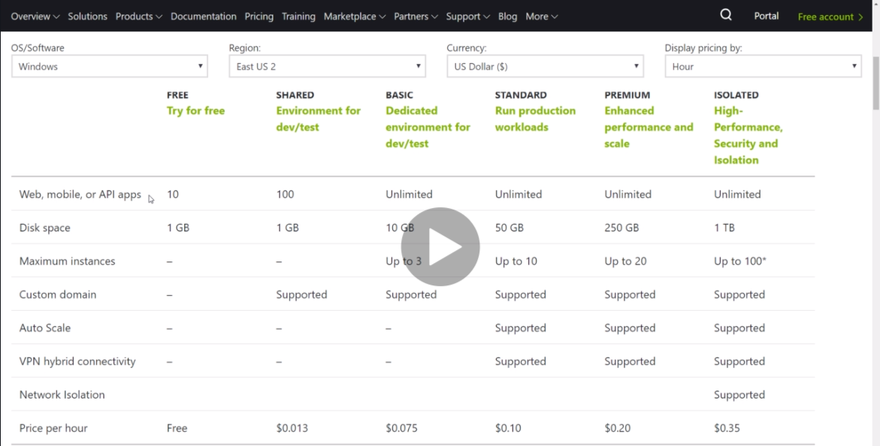
* Location of the app service plan is imp for low latencey for the local users. 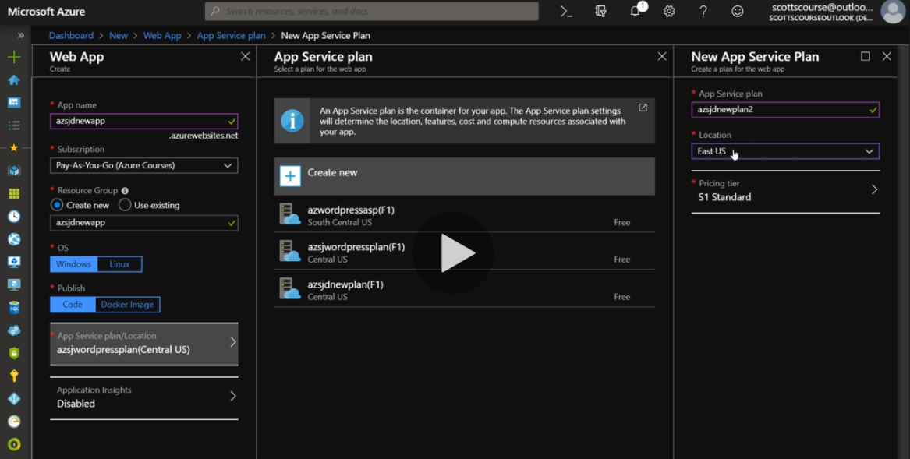
* Pricing tiers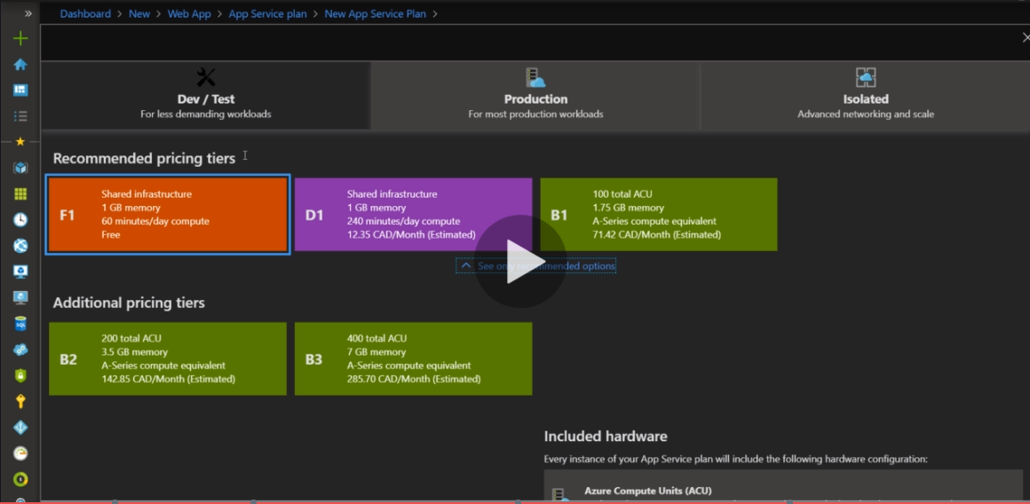
* App Service Plans <https://docs.microsoft.com/en-in/azure/app-service/overview-hosting-plans>
* There is a 100$ a month charge (for physical machinery) for Isolated plan apart from normal rates
* Using P1V2 is safest for the middle tier app and using this for demo as well.